Using online analysis and retrieval tools

Objective: In this computing exercise, you will have an opportunity to use two of the online analysis and retrieval tools: SDA and Nesstar. These tools can be used to do some basic, useful analysis with nothing more than a web browser. Both of the examples below use the General Social Survey and refer to your homework assignment for Wednesday night on pages 4.2 to 4.5.

General Social Survey using SDA, UC Berkeley

Task: Reproduce the table in your homework assignment on page 4.3.

http://sda.berkeley.edu/archive.htm

- Use the above URL to connect to the SDA Archive.
  - Click on GSS Cumulative Datafile 1972-2008.

- You will be using two variables: RELIG and YEAR. To reproduce the table in the homework assignment, you will need to recode the year variable from single years to ranges of years. Thus, you will be creating a new variable with values for each of the years in the table. You will create a name for the new variable below.
- From the SDA menu, hold the cursor over Create Variables and select Recode variables.

- Now you specify the recode. You will have to name the new variable in the provided text box.
- Create a variable name using “YR” plus the number of your workstation in the lab. E.g., YR024
- In box Var 1 under Name(s) of existing variables to use for the recode, enter YEAR.

- Under Recoding Rules, you will enter a different range of years in each of the first three rows. Fill in the boxes Value and Label and Var1 as shown in the screen shot on the next page.

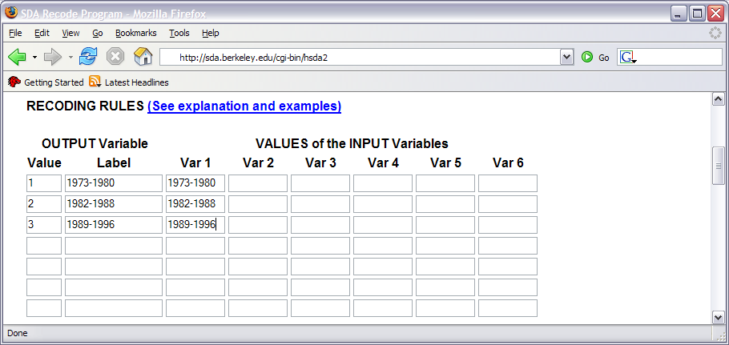

Figure 1
Screen shot of part of the form for recoding a variable in the SDA system.

- When done filling in the form, click the Start Recoding button. You will get a new browser window that shows your Recodes.

- Now you’ll specify the crosstabulation you want to build.
- Go to the window from which you issued the Recode command.
- From the SDA menu, hold the cursor over Analysis and select Frequencies or crosstabulation.
- Under Required, in the text box next to Row, type RELIG.
- Under OPTIONAL, in the text box next to Column, enter the variable name you created above.
- Next to Weight, use the drop list to show “No Weight.”
- In the Table Options box, under N of cases to display, check Unweighted and be sure that “Weighted” is not checked.
- In the same box, check Include missing-data values.
- Click the Run the Table button.

You should see a table that has the same values as the table in your homework assignment.

General Social Survey using NORC

http://www.norc.org/GSS+Website/Data+Analysis/

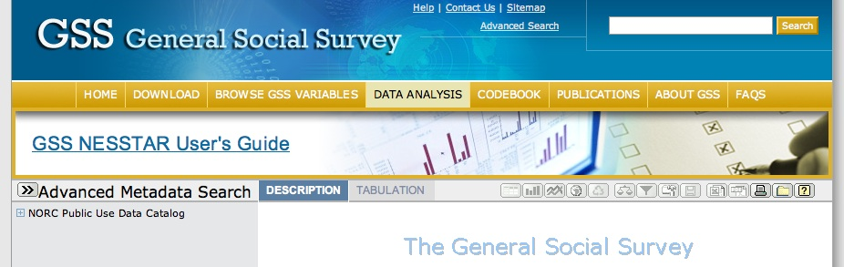

- Click on the small + icon beside NORC Public Use Data Catalog to display the list of studies and then click on this icon next to GSS.
- Display the documentation for the GSS by clicking on the table icon just to the left of the text “General Social Surveys, 1972-2006.”
- Open the Variable Description and select Mnemonic Index. Next find RELIG and click on the small “+” sign next to it to reveal RS RELIGIOUS PREFERENCE. Click on RS RELIGIOUS PREFERENCE to display the information for Religious Preference.

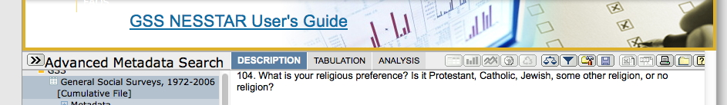

- From the menu next to “Advanced Metadata Search,” click on Tabulation.
- In the Mnemonic list, click on RS RELIGIOUS PREFERENCE and from the list that appears, click on Add to Row.
- Locate the variable for Year in the Mnemonic list, open it, and click on GSS YEAR FOR THIS RESPONDENT. In the list that appears, click on Add to column.
- From the toolbar next to Tabulation, select the Weight icon (balance scale).
- Click on WEIGHT VARIABLE WTSSNR and click the “>” symbol to add it to the “Weighting variables selected” box. Then click OK. The table should be redisplayed with “Weight is on” in red underneath the table.
- From the toolbar, select the subset icon (looks like a funnel).
- In the Mnemonic list, click on GSS YEAR FOR THIS RESPONDENT and, from the list that appears, select Add to subset.
- In the subset box on the right, click on the drop list and select “>=”. Then, under “Categories” click on 1973, and click ADD.
- Click More. From the new drop list, select “<=”. Then under “Categories” select 1980 and click Add. Click OK. A new table should appear, showing Religious preference for the years 1973-1980.
- Above the table, under “Type” change “column percentage” to Raw Numbers.
- From the toolbar, select the “Export table to spreadsheet” tool (a small “Excel” icon). Save the file to disk and name it (or rename it) “GSS1.xls”.
- From the toolbar, click on the download tool. Use the “Select data format” drop list that appears to select SPSS Portable. Click on Subset. From the “Categories” select 1996 and click Add.
- Click the tab Variables next to the tab “Cases.”
- In the Mnemonic variable list, click on GSS YEAR FOR THIS RESPONDENT. From the list that appears, select Add to subset.
- In the Mnemonic list, click on RS RELIGIOUS PREFERENCE. From the list that appears, select Add to subset.
- In the Mnemonic list, locate the weight variable, WTSSNR. Click on it and select Add to subset.
- Click OK.
- Click the Download button next to the SPSS Portable selection. A zip file with a numeric file name will download. Note the location and unzip the file.
- Start SPSS. Choose File -> Open -> Data. In the dialog box, change “Files of type” to SPSS Portable. Locate the unzipped file with the numeric name and the filename extension “.por”. Select it and open it.
- From the SPSS menu choose Data -> Weight Cases…
- In the dialog box, click on Weight Cases by. Then, double click on “Weight Variable WTSS….” And it should appear below “Frequency Variable.” Click OK.
- Now go to the main “data” window of SPSS and choose from the menu,
File -> New -> Syntax and a syntax editor window will open.
- In the syntax editor window type the following two lines:

RECODE year (1973 thru 1980=1) (1982 thru 1988=2) ( 1989 thru 1996=3) INTO yr.
Execute.

- From the SPSS menu, choose Run -> All. You should see the new variable “yr” in the SPSS Data view window.
- From the SPSS menu, select Analyze -> Descriptive Statistics -> Crosstabs. In the dialog box, click on Rs Religious Preference and add it to Rows by clicking the arrow next to the rows box. In the same way, add yr to Columns.
- Click on the cells button and add a check mark to column under percentages. Click continue.
- Click OK. Enjoy reading the Religious preference table you created in the SPSS output window! Compare it to the one in your homework booklet.
- At the bottom of the Data View window, click on the Variable View tab.
- Click on the cell under “Missing” in the “Relig” row. (Click just to the right of the “99”)
- In the Missing Values dialog box that opens, click on the radio button for “no missing values. Click OK.
- From the SPSS menu select Analyze -> Descriptive Statistics -> Crosstabs, and click OK.
- Does this more accurately replicate the table on page 4.3 of your homework booklet?

  - Quite SPSS by selecting File / Quit. Don’t save any of the windows.

NOTE: The online Data Analysis System (DAS) at ICPSR uses this same software (Survey Documentation and Analysis -- SDA) as we did above. See more about this system at ICPSR by going to: http://www.icpsr.umich.edu/icpsrweb/ICPSR/access/sda.jsp

Follow the “List all DAS studies” link on this page. How many studies are currently available? _________________

